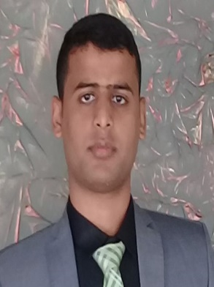
Ali Osman Mahmoud Mohamed
Luxor- Egypt
Mobile Phone: 01153122856///01279263379
aliosmanmahmoud4333@Yahoo.com

Personal Data:
- Date Of Birth : 12/2/1994
- Nationality : Egyptian
- Marital Status : Unmarried
- Military service : Done

Education:
Bachelor of Science
- University : Al-Azhar university (Asyut)
- Department : Special Chemistry
- Graduation Year : 2017
- Grade : Good
Courses & Training :
- Egypt Aluminum Company (Training )
- Egyptian Sugar & Integrated Industries Company (Training )
- Practical Training chemical Analysis at Esna Hospital
Computer skills :

- Ms office : word , Excel , power point &internet and Access

Experience :

- Fresh
Languages:

- Arabic : Mother tongue
- English : Native ( Writing & Reading and Speaking )
Personal Skills:
- Ability to work in a group or individually.
- Ability to work under pressure & Communicate.
- Quick to learn with good interpersonal and organizational skills.
- Quickly adapts to new systems and procedures.
- Quick to learn with good interpersonal and organizational skills.
- Quickly adapts to new systems and procedures.
Hobbies :
- Reading.
- Swimming.
- Listen music.
- Driving.

